CODE CHALLENGE MONGO DB

Case Study 1

db.createCollection("products")

db.products.insertMany([

{

"id": "1",

"product_name": "Intelligent Fresh Chips",

"product_price": 655.00,

"product_material": "Concrete",

"product_color": "mint green"

},

{

"id": "2",

"product_name": "Practical Fresh Sausages",

"product_price": 911.0,

"product_material": "Cotton",

"product_color": "indigo"

},

{

"id": "3",

"product_name": "Refined Steel Car",

"product_price": 690.00,

"product_material": "Rubber",

"product_color": "gold"

},

{

"id": "4",

"product_name": "Gorgeous Plastic Pants",

"product_price": 492.00,

"product_material": "Soft",

"product_color": "plum"

},

{

"id": "5",

"product_name": "Sleek Cotton Chair",

"product_price": 33.00,

"product_material": "Fresh",

"product_color": "black"

},

{

"id": "6",

"product_name": "Awesome Wooden Towels",

"product_price": 474.00,

"product_material": "Plastic",

"product_color": "orange"

},

{

"id": "7",

"product_name": "Practical Soft Shoes",

"product_price": 500.00,

"product_material": "Rubber",

"product_color": "pink"

},

{

"id": "8",

"product_name": "Incredible Steel Hat",

"product_price": 78.00,

"product_material": "Rubber",

"product_color": "violet"

},

{

"id": "9",

"product_name": "Awesome Wooden Ball",

"product_price": 28.00,

"product_material": "Soft",

"product_color": "azure"

},

{

"id": "10",

"product_name": "Generic Wooden Pizza",

"product_price": 84.00,

"product_material": "Frozen",

"product_color": "indigo"

},

{

"id": "11",

"product_name": "Unbranded Wooden Cheese",

"product_price":26.00,

"product_material": "Soft",

"product_color": "black"

},

{

"id": "12",

"product_name": "Unbranded Plastic Salad",

"product_price": 89.00,

"product_material": "Wooden",

"product_color": "pink"

},

{

"id": "13",

"product_name": "Gorgeous Cotton Keyboard",

"product_price": 37.00,

"product_material": "Concrete",

"product_color": "sky blue"

},

{

"id": "14",

"product_name": "Incredible Steel Shirt",

"product_price": 54.00,

"product_material": "Metal",

"product_color": "white"

},

{

"id": "15",

"product_name": "Ergonomic Cotton Hat",

"product_price": 43.00,

"product_material": "Rubber",

"product_color": "mint green"

},

{

"id": "16",

"product_name": "Small Soft Chair",

"product_price": 47.00,

"product_material": "Cotton",

"product_color": "teal"

},

{

"id": "17",

"product_name": "Incredible Metal Car",

"product_price":36.00,

"product_material": "Fresh",

"product_color": "indigo"

},

{

"id": "18",

"product_name": "Licensed Plastic Bacon",

"product_price":88.00,

"product_material": "Steel",

"product_color": "yellow"

},

{

"id": "19",

"product_name": "Intelligent Cotton Chips",

"product_price": 46.00,

"product_material": "Soft",

"product_color": "azure"

},

{

"id": "20",

"product_name": "Handcrafted Wooden Bacon",

"product_price": 36.00,

"product_material": "Concrete",

"product_color": "lime"

},

{

"id": "21",

"product_name": "Unbranded Granite Chicken",

"product_price": 90.00,

"product_material": "Metal",

"product_color": "gold"

},

{

"id": "22",

"product_name": "Ergonomic Soft Hat",

"product_price": 99.00,

"product_material": "Rubber",

"product_color": "black"

},

{

"id": "23",

"product_name": "Intelligent Steel Pizza",

"product_price": 95.00,

"product_material": "Cotton",

"product_color": "azure"

},

{

"id": "24",

"product_name": "Tasty Rubber Cheese",

"product_price":47.00,

"product_material": "Frozen",

"product_color": "orchid"

},

{

"id": "25",

"product_name": "Licensed Steel Car",

"product_price":20.00,

"product_material": "Cotton",

"product_color": "indigo"

}

])

**FINDING THE INFORMATION ABOUT EACH PRODUCT**

db.products.find().pretty()

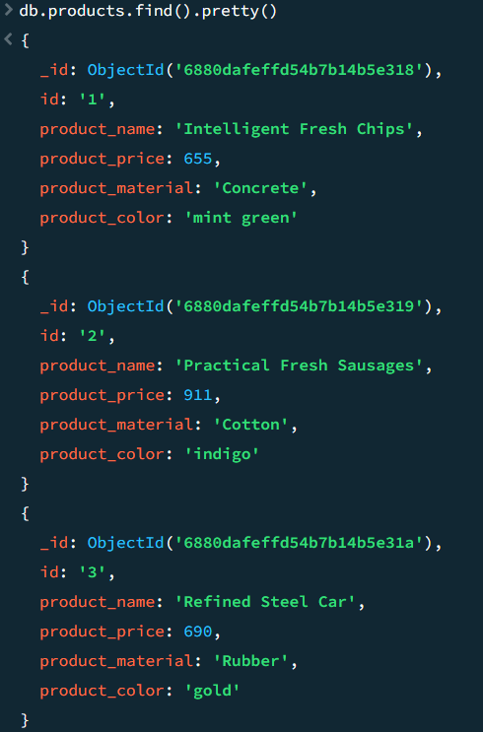

**FINDING PRODUCTS WHICH PRICE BETWEEN 400 TO 800**

db.products.find({ product_price: { $gte: 400, $lte: 800 } })

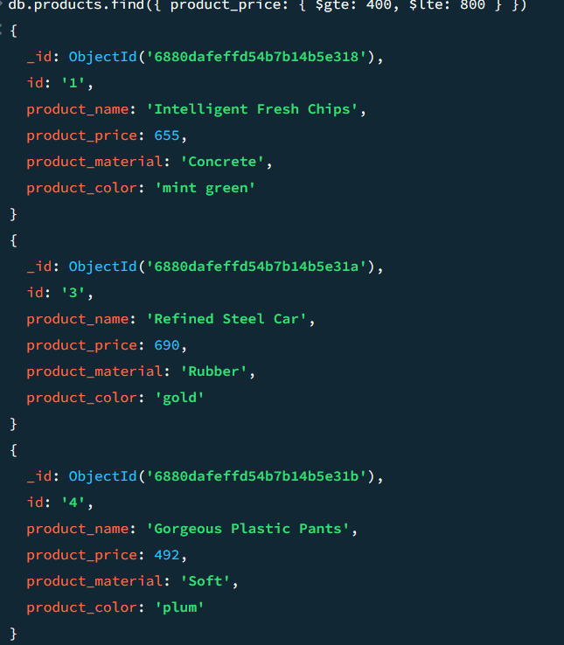

**LIST OF PRODUCTS WITH PRICE MORE THAN 500**

db.products.find({ product_price: { $gt: 500 } }).limit(4)

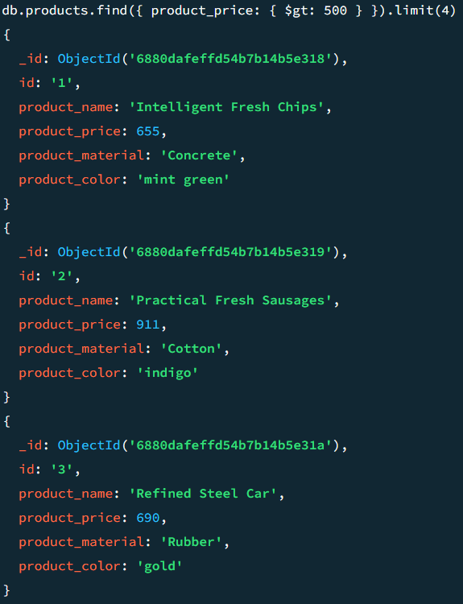

**FINDING PRODUCT WITH ROW ID 10**

db.products.find({ id: "10" })

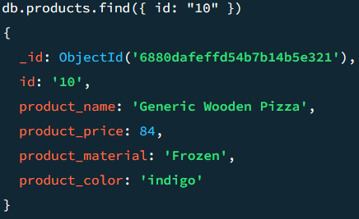

**FINDING PRODUCT NAME AND MATERIAL OF EACH TYPE**

db.products.find({}, { _id: 0, product_name: 1, product_material: 1 })

